**MIDDLETON CHENEY FOOTBALL CLUB**

**ANNUAL GENERAL MEETING**

**1989**

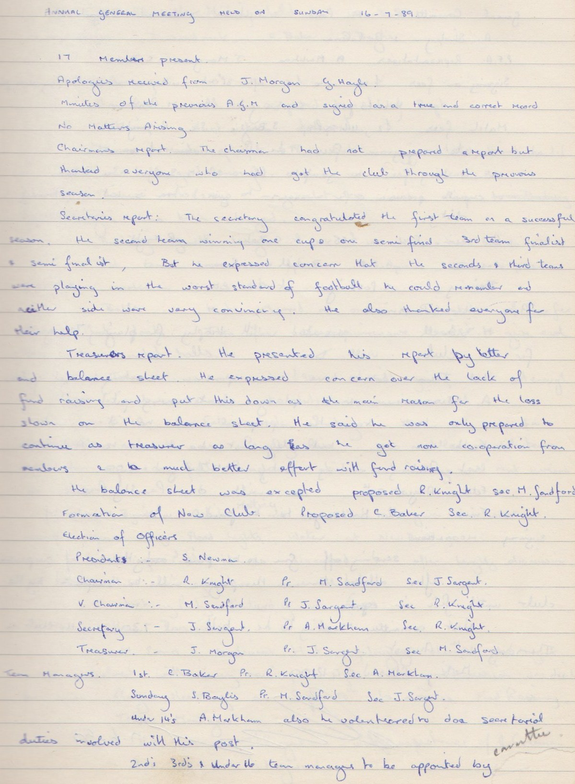

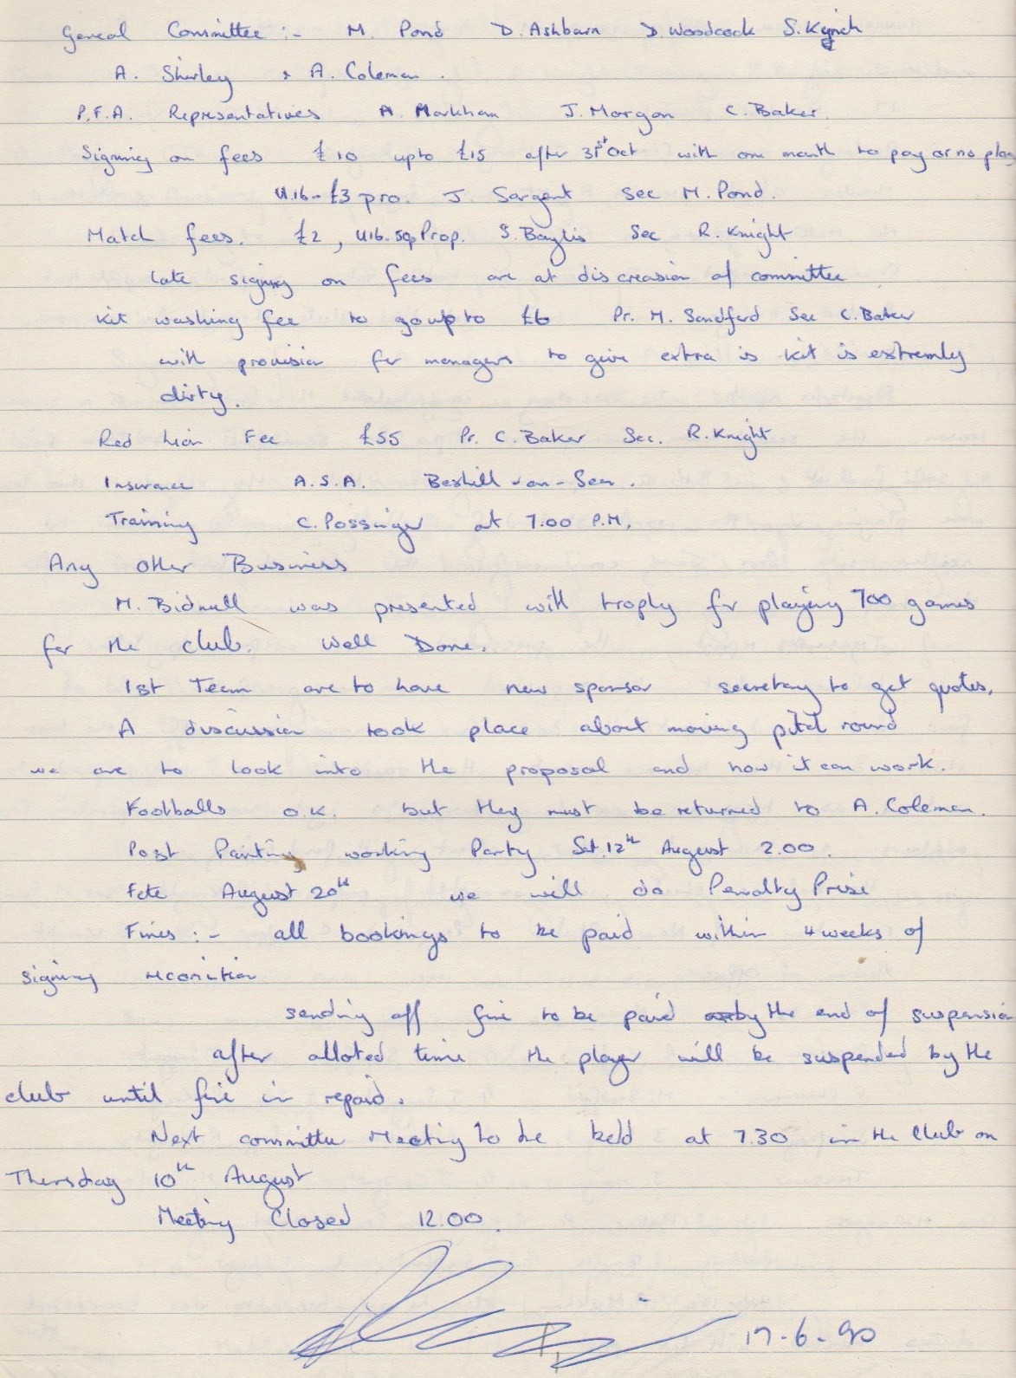

**General Committee Meeting**

**August 10th 1989**

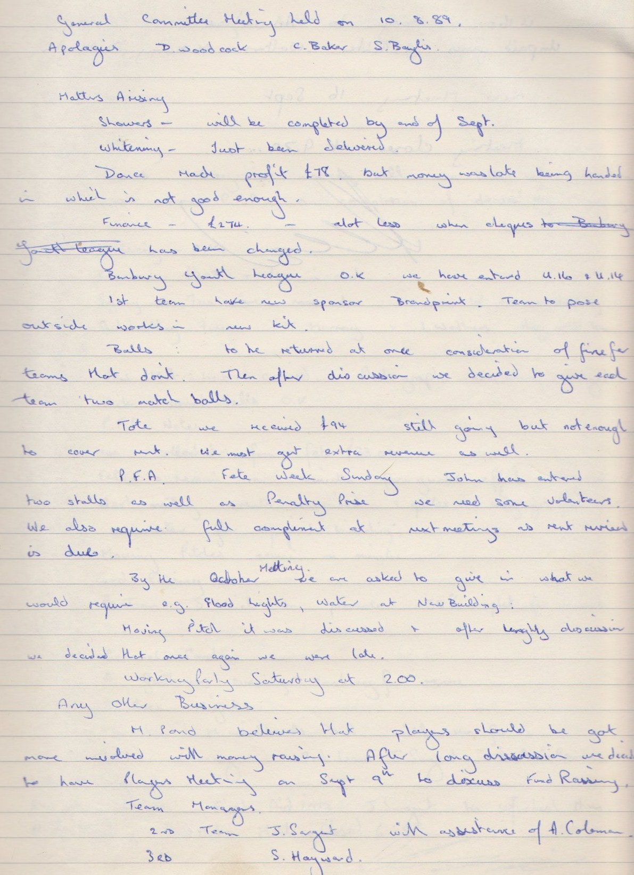

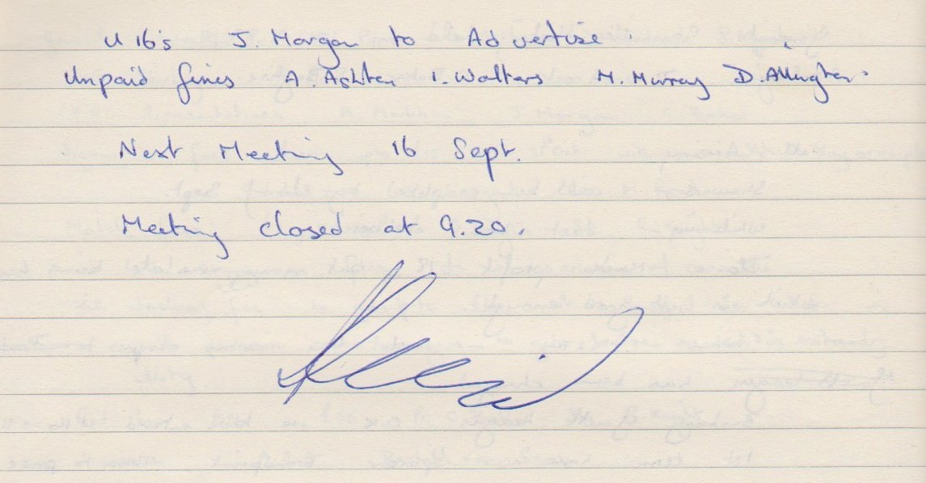

**General Committee Meeting**

**September 23rd 1989**

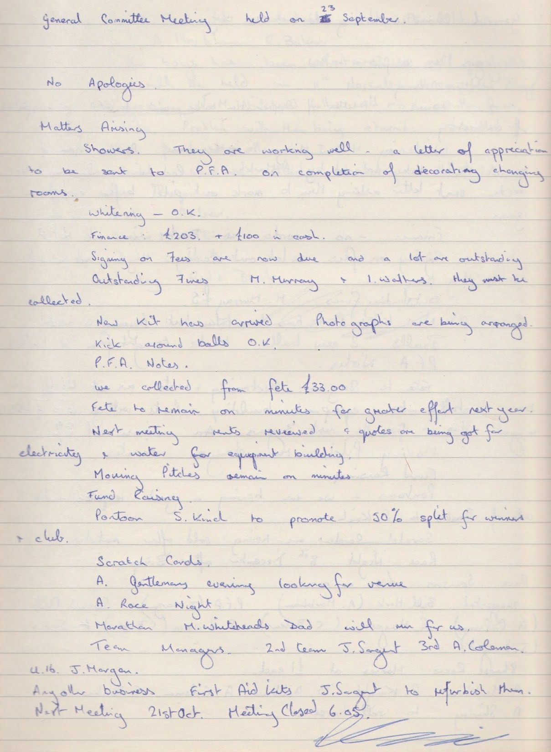

**General Committee Meeting**

**October 21st 1989**

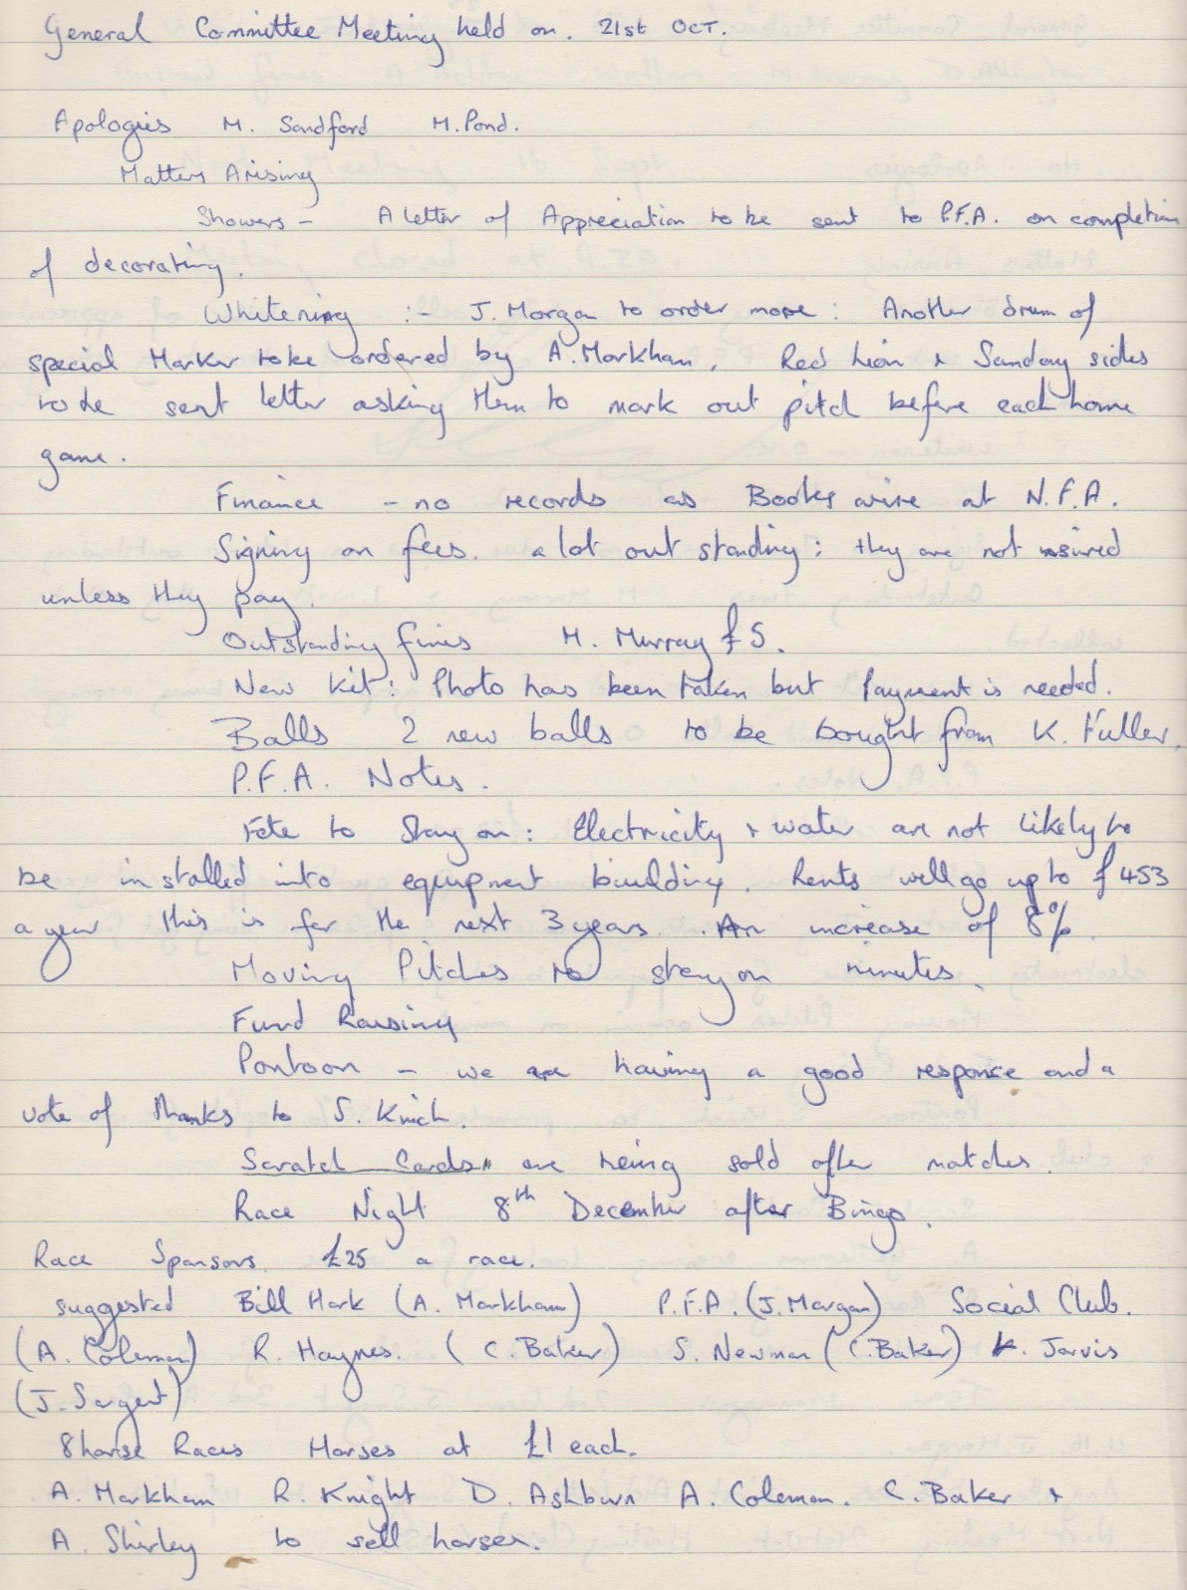

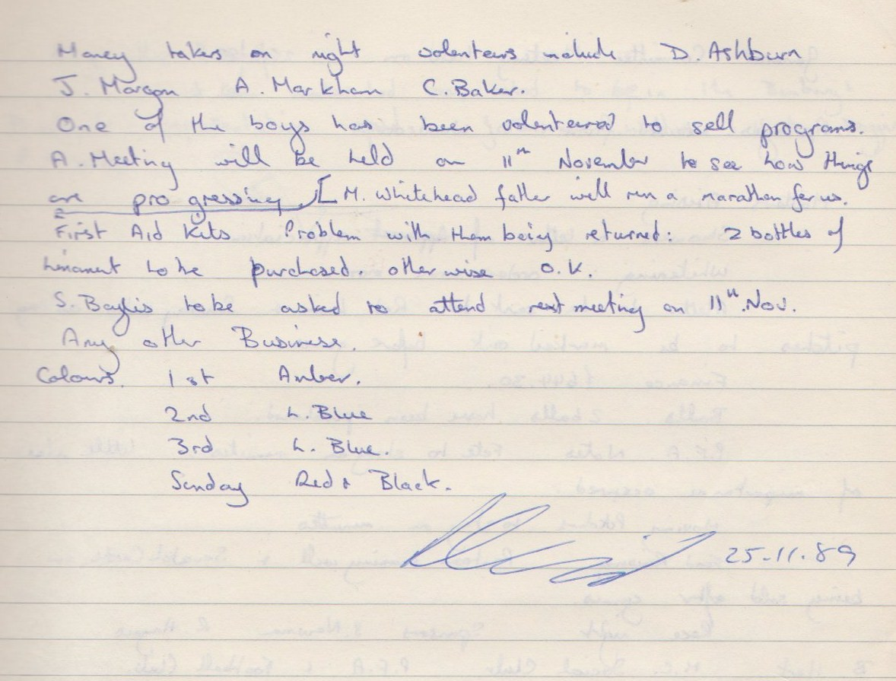

**General Committee Meeting**

**November 25th 1989**

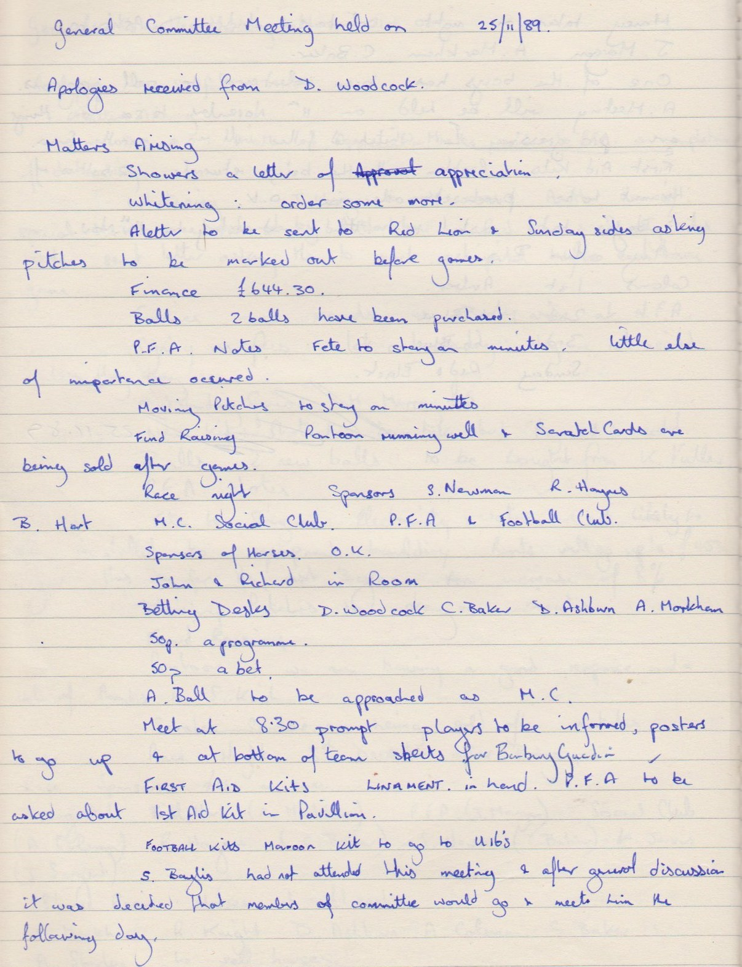

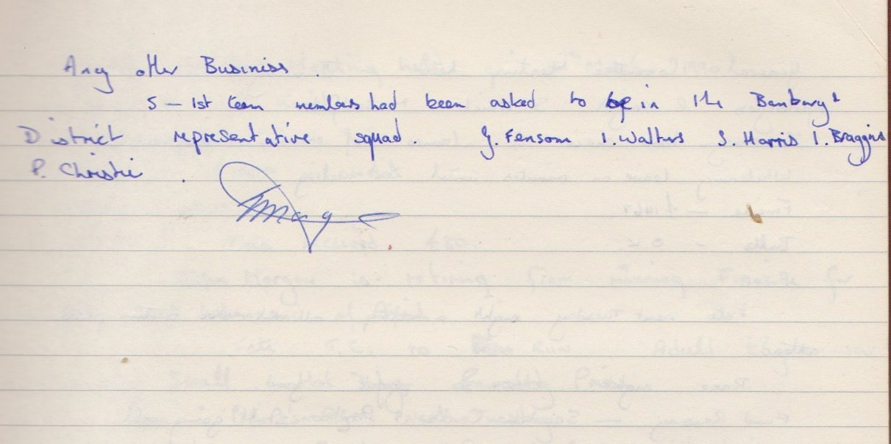

**General Committee Meeting**

**January 1990**

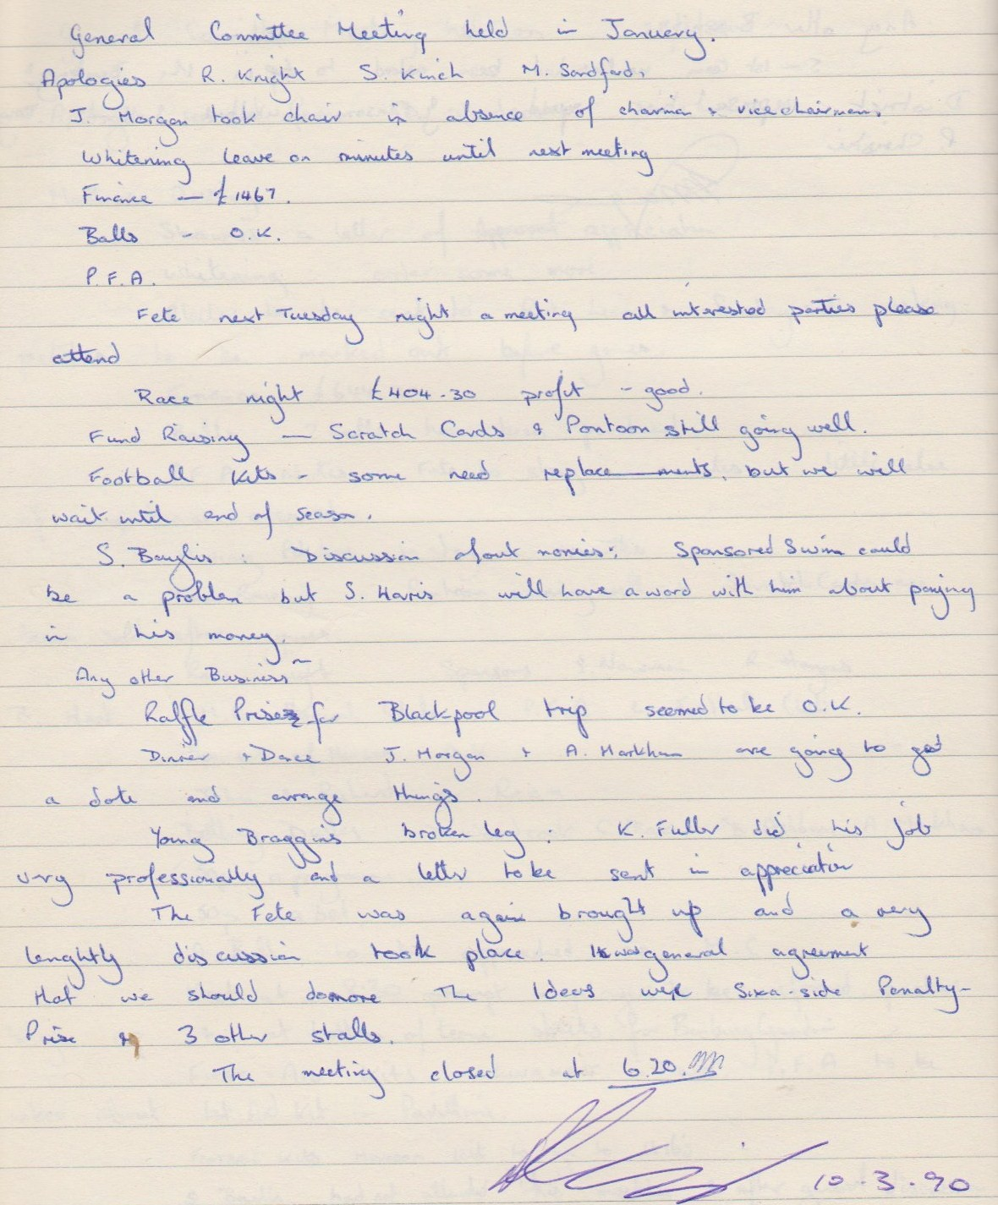

**General Committee Meeting**

**March 10th 1990**

